-- создаем БД

CREATE DATABASE HomeFriends;

Use HomeFriends;

-- таблица Кошки

Create Table Cats (

id INT PRIMARY KEy AUTO_INCREMENT,

name Varchar(45) Not NULL,

type Varchar(45) Not NULL,

birth_date Date Not NULL,

command Varchar(45)

);

INSERT INTO Cats (name,type,birth_date, command)

Values

('Murka','cat','2023-01-26','Sit, Pounce'),

('Barsik','cat','2018-09-30','Sit, Pounce, Scratch'),

('Kitty','cat','2024-05-13','Sit, Pounce'),

('Fedor','cat','2020-07-07','Meow, Scratch, Jump'),

('Tomka','cat','2014-11-06','Jump, Pounce');

Select * from Cats;

-- таблица Собаки

Create Table Dogs (

id INT PRIMARY KEy AUTO_INCREMENT,

name Varchar(45) Not NULL,

type Varchar(45) Not NULL,

birth_date Date Not NULL,

command Varchar(45)

);

INSERT INTO Dogs (name,type,birth_date, command)

Values

('Torik','dog','2023-01-26','Sit, Stay, Fetch'),

('Charley','dog','2018-09-30','Sit, Stay, Roll'),

('Djeck','dog','2024-05-13','Sit, Paw, Bark'),

('Guchka','dog','2020-07-07','Sit, Stay, Fetch'),

('Polka','dog','2014-11-06','Sit, Paw, Bark');

Select * from Dogs;

-- таблица Хомяки (а это наш хомяк Понька 😊)



Create Table Hamsters (

id INT PRIMARY KEy AUTO_INCREMENT,

name Varchar(45) Not NULL,

type Varchar(45) Not NULL,

birth_date Date Not NULL,

command Varchar(45)

);

INSERT INTO Hamsters (name,type,birth_date, command)

Values

('Ponka','hamster','2023-01-26','Roll, Hide'),

('Valerka','hamster','2023-09-30','Roll, Spin'),

('Pushok','hamster','2024-05-13','Roll, Hide'),

('Homka','hamster','2022-07-07','Roll, Spin'),

('Vaka','hamster','2013-11-06','Roll, Hide');

Select * from Hamsters;

-- таблица Лошади

Create Table Horses (

id INT PRIMARY KEy AUTO_INCREMENT,

name Varchar(45) Not NULL,

type Varchar(45) Not NULL,

birth_date Date Not NULL,

command Varchar(45)

);

INSERT INTO Horses (name,type,birth_date, command)

Values

('Storm','horse','2023-05-26','Trot, Canter, Gallop'),

('Chernish','horse','2017-09-24','Trot, Jump, Gallop'),

('Apple','horse','2015-05-13','Trot, Canter, Gallop'),

('Zorka','horse','2022-07-07','Trot, Canter'),

('Bystraya','horse','2013-11-06','Trot, Canter, Gallop');

Select * from Horses;

-- Таблица Верблюды

Create Table Camels (

id INT PRIMARY KEy AUTO_INCREMENT,

name Varchar(45) Not NULL,

type Varchar(45) Not NULL,

birth_date Date Not NULL,

command Varchar(45)

);

INSERT INTO Camels (name,type,birth_date, command)

Values

('Dune','camel','2023-05-26','Walk, Run'),

('Wind','camel','2017-09-24','Walk, Sit'),

('Snow','camel','2015-05-13','Walk, Carry Load'),

('Red_wings','camel','2022-07-07','Walk, Carry Load'),

('Grygoriy','camel','2013-11-06','Walk, Sit');

Select * from Camels;

-- таблица Ослы

Create Table Donkeys(

id INT PRIMARY KEy AUTO_INCREMENT,

name Varchar(45) Not NULL,

type Varchar(45) Not NULL,

birth_date Date Not NULL,

command Varchar(45)

);

INSERT INTO Donkeys (name,type,birth_date, command)

Values

('Gosha','donky','2023-05-26','Walk, Carry Load, Bray'),

('Petka','donky','2017-08-24','Walk, Bray, Kick'),

('Slow','donky','2015-05-12','Walk, Carry Load, Bray'),

('Fast','donky','2020-07-07','Walk, Bray, Kick'),

('Innikentiy','donky','2013-11-06','Walk, Carry Load, Bray');

Select * from Donkeys;

-- создаем таблицу для всех вьючных животных и добавляем в нее ослов, лошадей и верблюдов

Create Table PackPets(

SELECT name, type, birth_date, command, ‘from Horses’ as from_table

FROM Horses

UNION ALL

SELECT name, type, birth_date, command, ‘from Camels’

FROM Camels

UNION ALL

SELECT name, type, birth_ date, command, ‘from Donkey’

FROM Donkeys);

-- верблюды уехали на зимовку, их удаляем

DELETE FROM PackPets

WHERE id>0 and type = 'camel';

select * from PackPets;

-- Создаем таблицу домашних любимцев и добавляем в нее хомяков, котов и собак

Create Table Pets AS (

SELECT name,type,birth_date, command, 'from Hamsters' as from_table

FROM Hamsters

UNION ALL

SELECT name,type,birth_date, command, 'from Cats'

FROM Cats

UNION ALL

SELECT name,type,birth_date, command, 'from Dogs'

FROM Dogs

);

Select * from Pets;

-- создаем общую таблицу для домашних животных

Create Table HomeFriends(

SELECT *

FROM Pets

UNION ALL

SELECT *

FROM PackPets);

select* from HomeFriends;

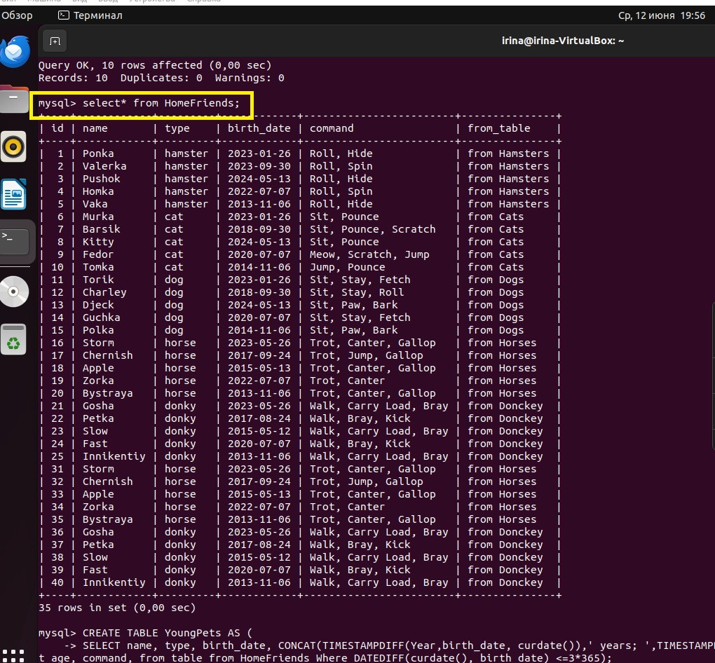

-- отдельно создаем таблицу молодых животных и вычисляем точный возраст

CREATE TABLE YoungPets AS (

SELECT name, type, birth_date,

CONCAT(TIMESTAMPDIFF(Year,birth_date, curdate()),' years; ',TIMESTAMPDIFF(MONTH,birth_date, curdate())%12,' months' ) as current_age, command, from_table

FROM HomeFriends

WHERE DATEDIFF(curdate(), birth_date) <=3*365);

Select * from YoungPets;

